**BETHLAHEM INSTITUTE OF ENGINEERING**

(Affiliated to AICTE & ANNA UNIVERSITY)

**DEPARTMENT OF COMPUTER SCIENCE ENGINEERING**

**REPORT ON**

**HX8001 PROFESSION READNESS FOR INNOVATION,**

**EMPOLYABILITY AND ENTREPENEURSIP**

**PROJECT TITLE**

**SMART SOLUTIONS FOR RAILWAYS**

**A PROJECT REPORT**

**Submitted by**

**TEAM ID – PNT2022TMID51289**

**TEAM MEMBERS** **MENTOR**

1.R.S. GLADY SHAJEENA (Team Leader) Mr. P.LIBIN JACOB

2.K. SARANYA **EVALUATOR**

3.JERIL JAMES Mrs. G. MARLY

4.SELCIYA N

# 

# INDEX

# 1. INTRODUCTION

1.1 Project Overview

1.2 Purpose

# 2. LITERATURE SURVEY

2.1 Existing problem

2.2 References

2.3 Problem Statement Definition

# 3. IDEATION & PROPOSED SOLUTION

3.1 Empathy Map Canvas

3.2 Ideation & Brainstorming

3.3 Proposed Solution

3.4 Problem Solution fit

# 4. REQUIREMENT ANALYSIS

4.1 Functional requirement

4.2 Non-Functional requirements

# 5. PROJECT DESIGN

5.1 Data Flow Diagrams

5.2 Solution & Technical Architecture

5.3 User Stories

# 6. PROJECT PLANNING & SCHEDULING

6.1 Sprint Planning & Estimation

6.2 Sprint Delivery Schedule

6.3 Reports from JIRA

# 7. CODING & SOLUTIONING

7.1 Feature 1

7.2 Feature 2

7.3 Database Schema (if Applicable)

# 8. TESTING

8.1 Test Cases

8.2 User Acceptance Testing

1. **RESULTS**

9.1 Performance Metrics

# 10. ADVANTAGES & DISADVANTAGES 11. CONCLUSION 12. FUTURE SCOPE 13. APPENDIX

Source Code

GitHub & Project Demo Link

# ABSTRACT

* The developed countries has been implemented smart train using internet of things (IOT). The Indian Railways (IR) carries about 5.5 lakhs passengers in reserved accommodation every day. The Computerised Passenger Reservation System (PRS) facilities the booking and cancellation of tickets from any of the 4000 terminals (i.e. PRS booking window all over the countries).

* These tickets can be booked or cancelled for journeys commencing in any part of India and ending in any other part, with travel time as long as 72hours and distance up to several thousand kilo meters.

* In the given project we will be developing a website which will help users to find train details, book and cancel tickets and the exact rates of their tickets to the desired destination. With the help of online booking people can book their tickets online through internet, sitting in their home by a single click of mouse. Using their credit cards people can easily get their tickets done within minutes.

**INTRODUCTION**

# ➢ Project Overview

Our website has various kinds of information that helps regarding booking of tickets via railways. Users will be able to search the train availability, the exact fare ,the arrival and departure time of the train and they can also book the ticket by using the debit ,credit or master card and after booking the ticket if the user want to cancel it then they can easily do it also. Railway passengers frequently need to know about their ticket reservation status, ticket availability on a particular train or for a place, train arrival or departure details, special trains etc.. Customer information Center at the railway stations are unable to serve such queries at peak periods. The number of the reservation counters available to the passengers and customers are very less. On most of the reservation systems there are long queues, so it takes a long time for any individual to book the ticket. As now there are no call centers facilities available to solve the queries of the passengers. The online railway ticket reservation system aims to develop a web application which aims at providing trains details, trains availability, as well as the facility to book ticket in online for customers.

**LITERATURE SURVEY**

# ➢ Existing problem

In the existing reservation system, booking itself includes two types of methodologies. One is PRS System and the other one is Online booking which is provided by IRCTC. In both the cases we need to enter details such as name, age, gender, preference and other things. After that availability will checked and booking will be completed as per the wish. This even includes the payment gateway also. In the current system there are many disadvantages which are to be rectified. The main thing which comes under is about allocation of lower berths. Even for senior citizens, medically ill and pregnant ladies. During Verification there are possibilities for fake identification also. So, there could possibility of unauthenticated travel by stranger also. More over the main disadvantage is about payment for waiting list passengers and un travelled passengers.

# References

1. Khekare G S, Sakhare A V. A smart city framework for intelligent traffic system using VANET[C]// International Multi-conference on Automation. IEEE, 2013.
2. COOPER Dave E. Intelligent transportation systems for smart cities: a progress review[J]. Science China(Information Sciences), 2012, 55(12):2908-2914.
3. Stefansson G, Lumsden K. Performance issues of Smart Transportation Management systems[J]. International Journal of Productivity & Performance Management, 2009, 58(1):55-70.
4. Huang X. Smart Antennas for Intelligent Transportation Systems[C]// International Conference on ITS Telecommunications Proceedings. IEEE, 2006:426-429.
5. Li X, Song J. The Top Design Methodology of Smart City in China[C]// International Conference on Intelligent Computation Technology and Automation. IEEE, 2014:861-864.
6. Jianbo, Cheng, Peng. Top-Level Design of Smart City Based on "Integration of Four Plans"[J]. ZTE Communications, 2015, 13(4):34-39.
7. Lanke N, Koul S, Lanke N, et al. Smart Traffic Management System[J]. International Journal of Computer Applications, 2014, 75(7):19-22.
8. Bouhedda M, Bellatreche S, Ahmed-Serier R. Smart traffic signal controller design and hardware implementation-based ant colony system[C]// International Conference on Modelling, Identification and Control. IEEE, 2017:1110-1116.

## Problem Statement Definition

➢ Our aim is to make a online application for ticket reservation and seat reservation by using QR code. Smart Solutions For Railways System. Need of big server to make easy of ticket booking. Webpage need to maintained with the ratio with number of users booking ticket.

## IDEATION& PROPOSED SOLUTION

### Empathy Map Canvas

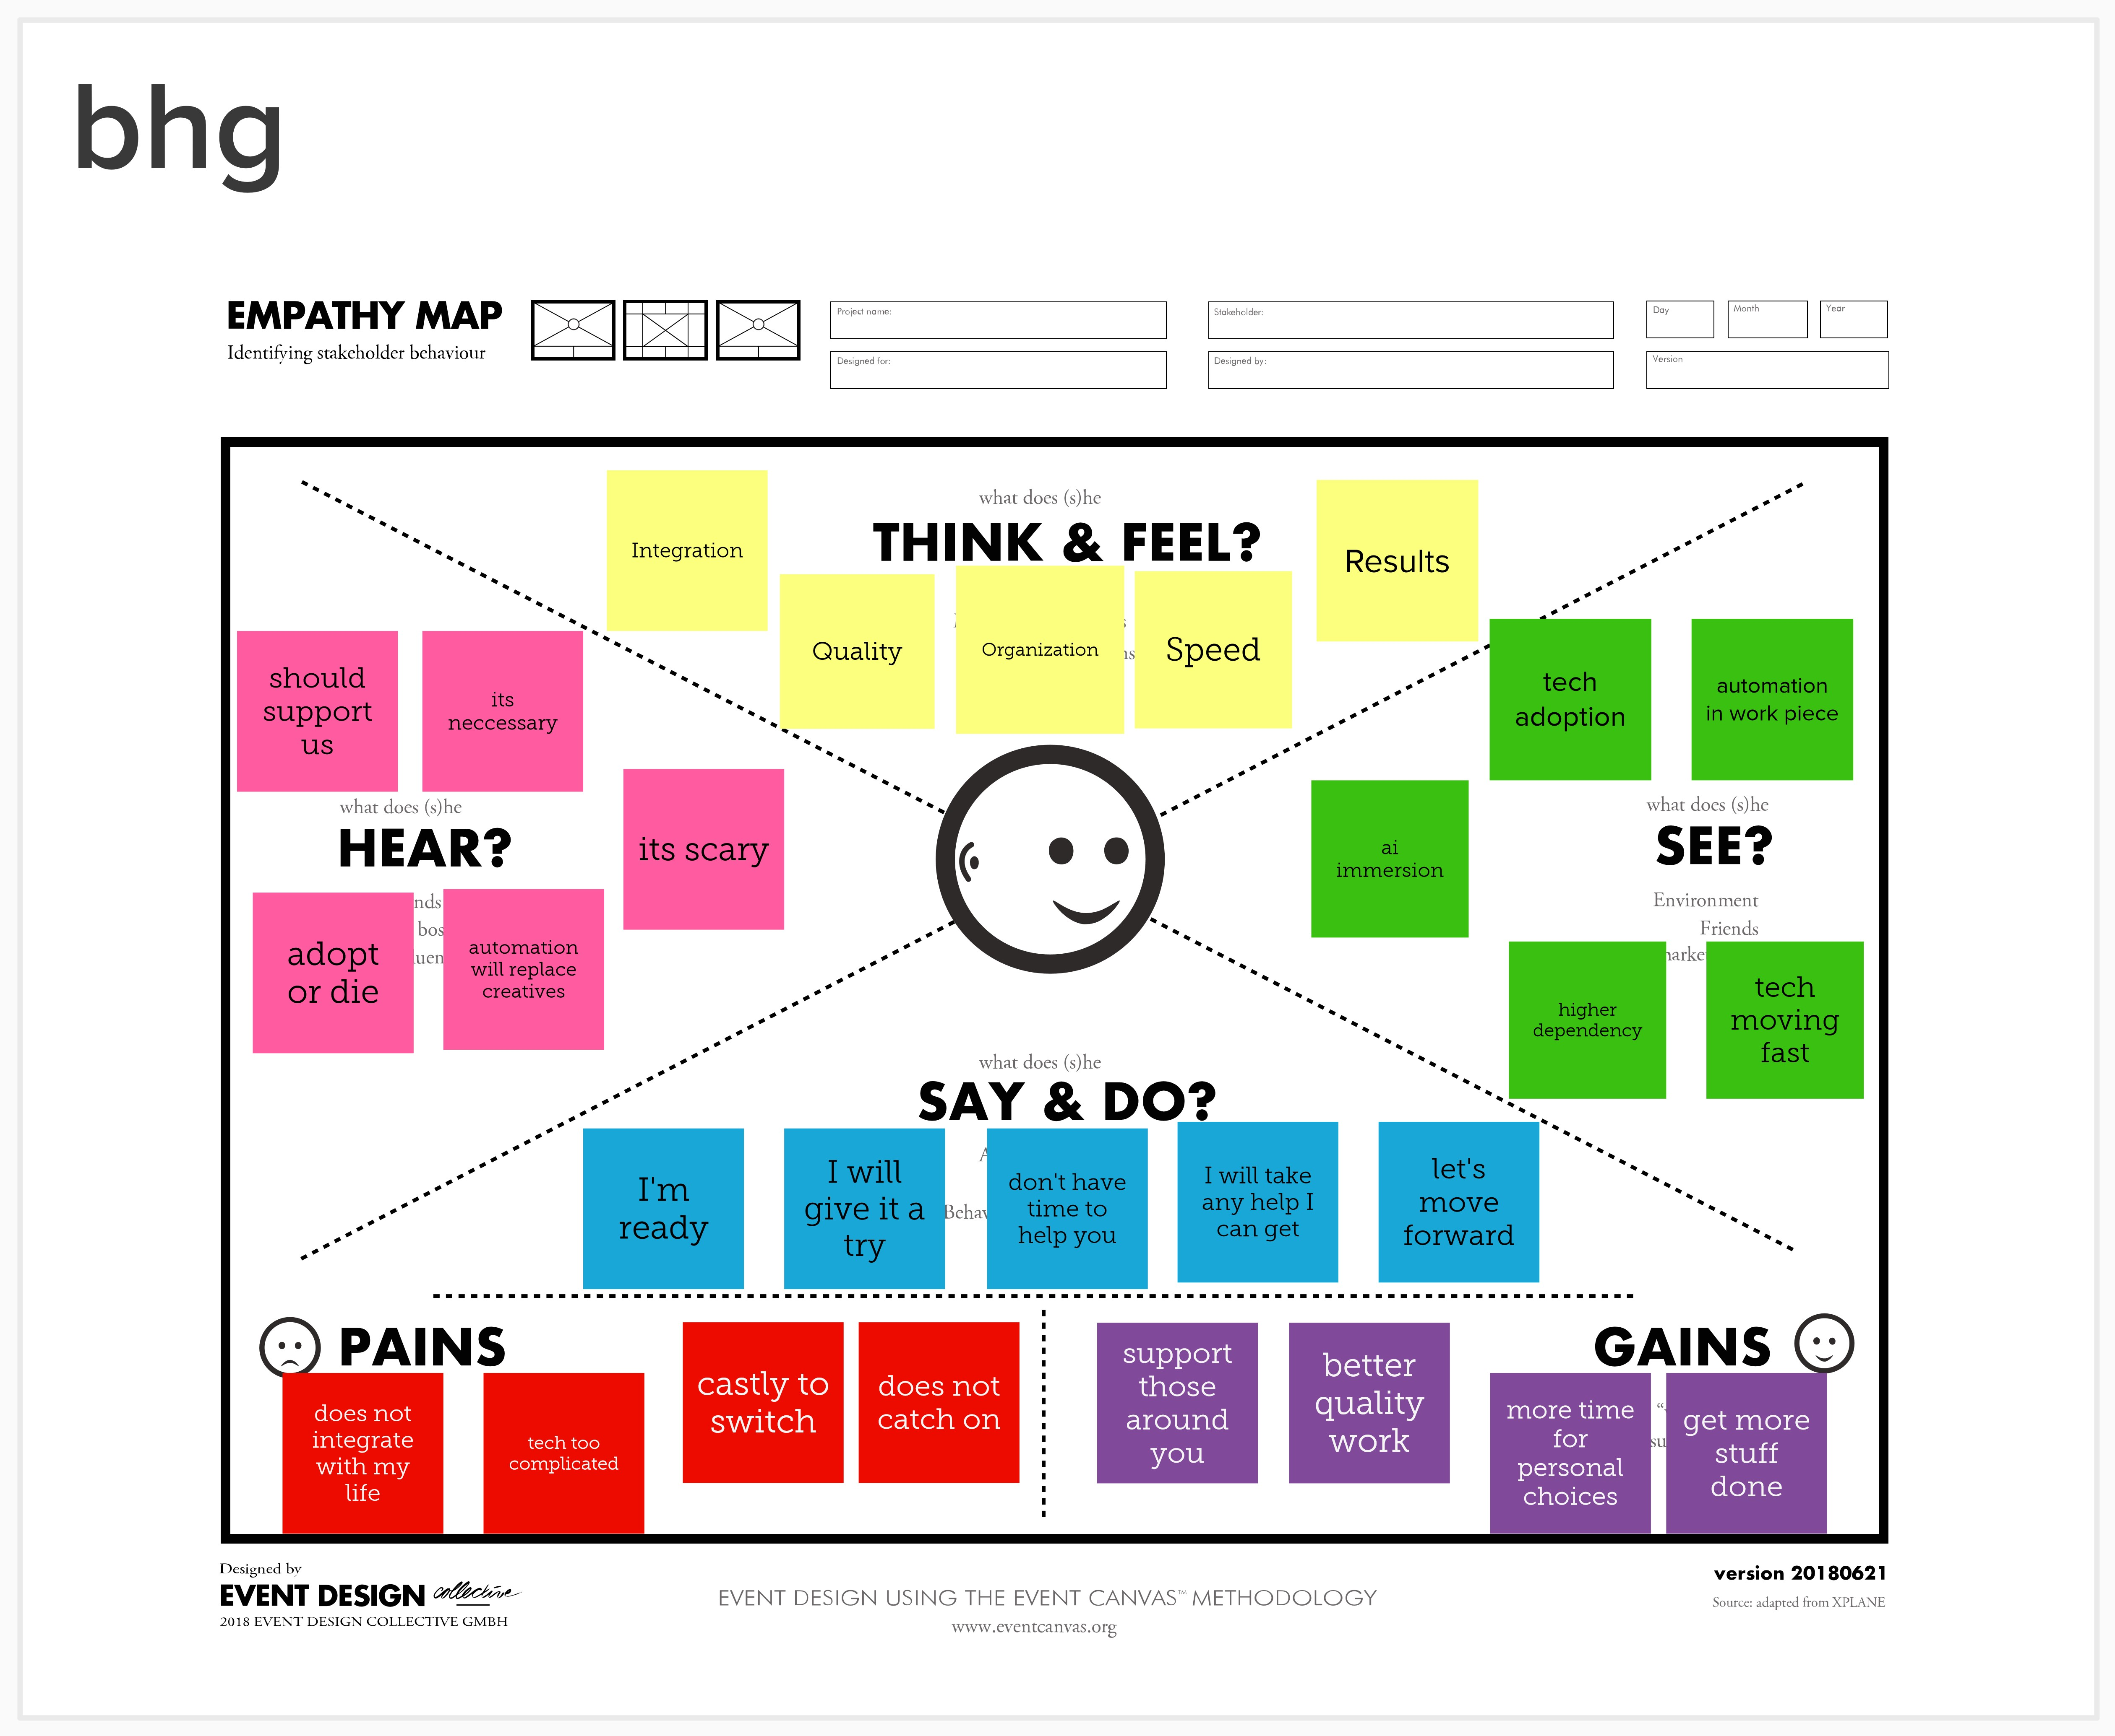

## Ideation & Brainstorming

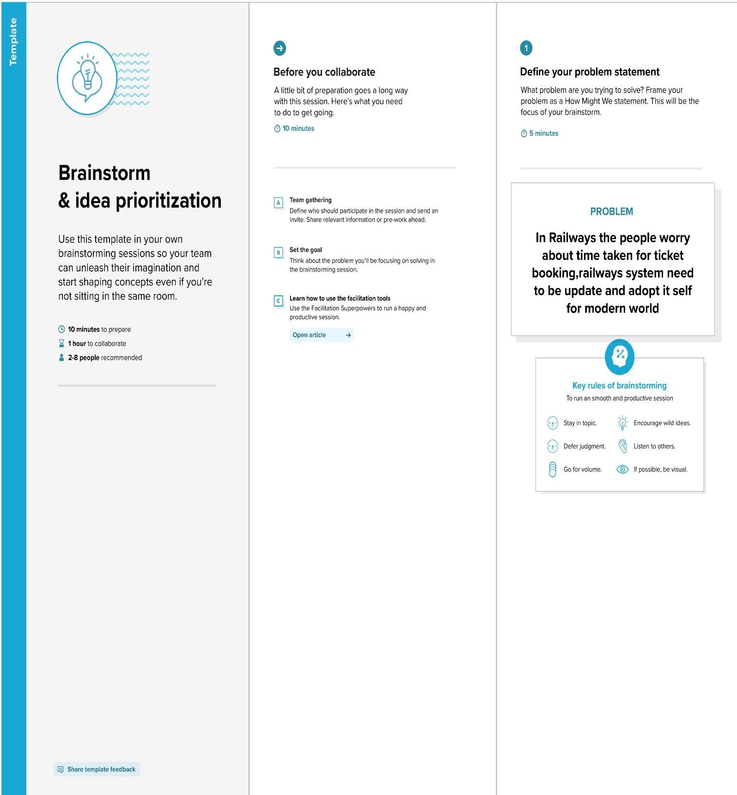

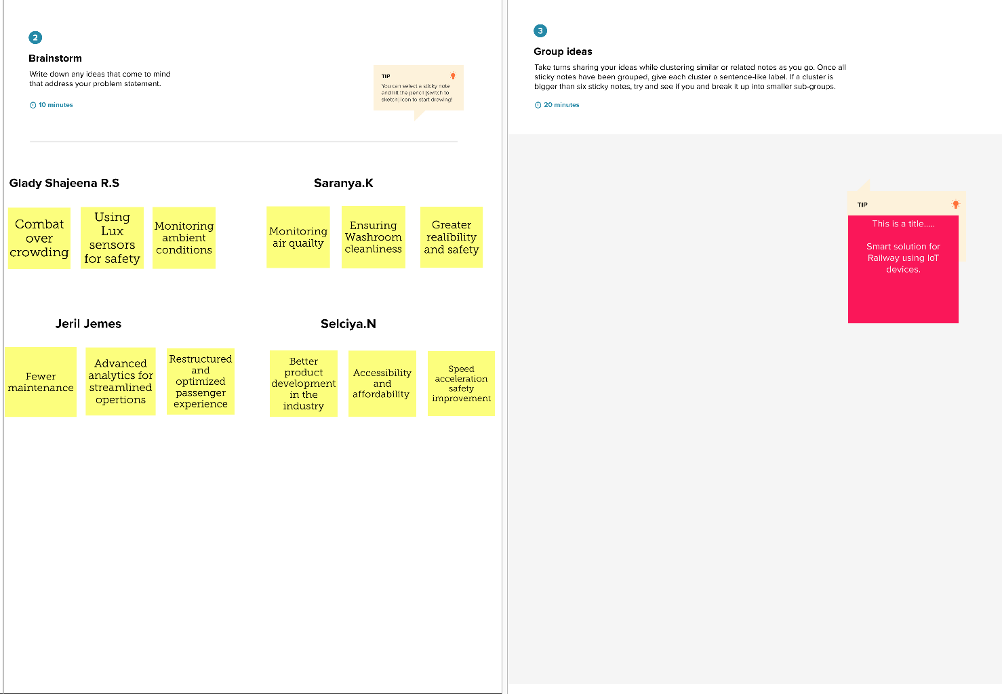

## Proposed Solution

|  |  |  |
| --- | --- | --- |
| **S.NO.** | **PARAMETER** | **DESCRIPTION** |
| 1. | Problem Statement (Problem to be solved) | Nowadays a lot of students have great skills but unable to get a desired/appropriate job, so an end-to-end web application can be created which is capable of displaying current job openings based on user skill set making it easier to hire and get hired. |
| 2. | Idea / Solution description | To develop an end-to-end web application which in default have a lot of current job openings through job search API out of which appropriate job will be recommended based on user skill set. At the same time students can develop their skills side by side with various courses and webinars offered by reputed organization. In addition to this a smart chat bot will be available for 24*7 which can help users in finding the right job. |
| 3. | Novelty / Uniqueness | Though we have a lot of job searching applications, this one is unique because,   * We have a smart chatbot built with IBM Watson * Our platform not only helps in getting job but also helps in developing skills to get right job * Here you can save/bookmark jobs for later use and also turn on notification for company specific job alerts * Add media files to your profile to showcase your achievements * It is made responsive to all screen sizes |
| 4. | Social Impact / Customer Satisfaction | Students will be benefited as they will get to know which job suits them based on their skill set and therefore Lack of Unemployment can be reduced. |
| 5. | Business Model (Revenue Model) | We can provide the application for job seekers in a subscription based and we can share the profiles with companies and generate the revenue by providing them best profiles. |
| 6. | Scalability of the Solution | Data can be scaled up and scaled down according to number of current job openings available. |

# Problem solution fit

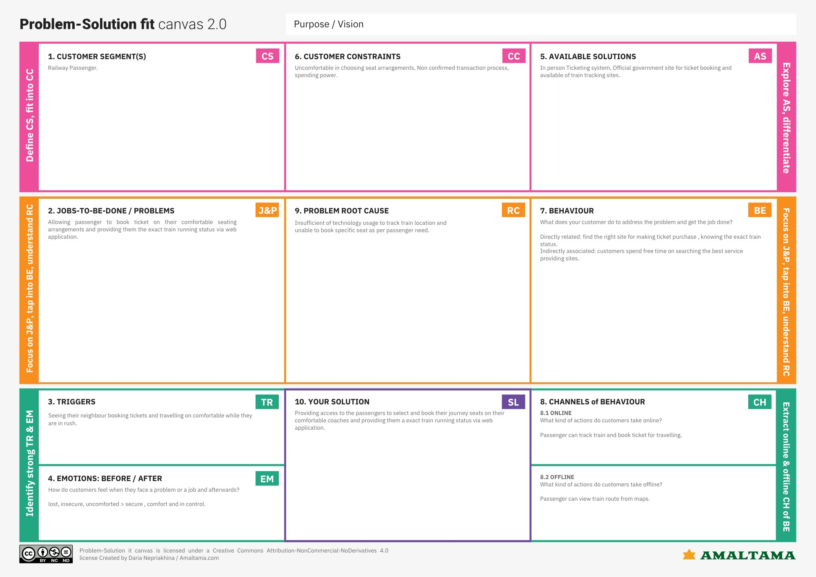

# REQUIREMENT ANALYSIS

## Functional Requirement

|  |  |  |
| --- | --- | --- |
| **FR No.** | **Functional Requirement (Epic)** | **Sub Requirement (Story / Sub-Task)** |
| FR-1 | User Registration | If Passenger want to book tickets. Firstly, they need to register as new user in web app. User need to enter email or phone number and create strong password for registration |
| FR-2 | User verification | The verification code is sended to the registered email id or phone number for registration. |
| FR-3 | User confirmation | The verification code is entered in to the app application. After finishing that home page is opened. After verification, user can proceed to login with valid credential. |
| FR-4 | Process of booking | When the home page is opened there will be a from and to option. Then, the passenger has to provide his/her details with the date of the journey, names of the passengers and their details, origin station details, destination station details, and the class type of the required ticket(s)  The Railway Reservation System will provide the available Train-list, and Seat-availability, via-details. |
| FR-5 | Payment process | To book a ticket passengers can pay through online/offline mode.  If the passenger select online payment mode, the ui shows lot of payment option like net banking, upi, card payment.  Through various option the passenger can done payment and it can be done by in secure manner. |
| FR-6 | Confirmation message | After done the payment, ticket is booked. The confirmation will sent to register email or phone number.  E-ticket will be sent and also QR code sent to register email id and phone number.  Passenger can show the QR code to ticket collector for verification. If the ticket collector scan the QR code then the passenger details will shown in his/her gadget screen |

## 

## Non-functional Requirements

|  |  |  |
| --- | --- | --- |
| **FR No.** | **Non-Functional Requirement** | **Description** |
| NFR-1 | **Usability** | The web app can easily accessible because of it’s sleek and simple user interface |
| NFR-2 | **Security** | The web app can access only by valid user and password credential. The payment gateway have lot of security |
| NFR-3 | **Reliability** | In the process booking ticket, passenger may face session timed out or network error. The web app auto save option. Therefore, lot of time is saved |
| NFR-4 | **Performance** | The application is work faster with good network connection |
| NFR-5 | **Availability** | QR code is sended through the message and email id or phone number |
| NFR-6 | **Scalability** | Session management is available for web app. Numerous user can access the web app easily. |

### PROJECT DESIGN

Data Flow Diagrams

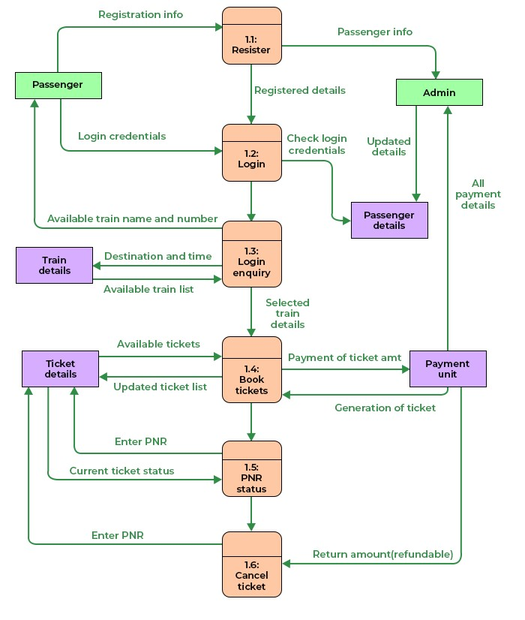

### Solution & Technical Architecture

* As trains are one of the most preferred modes of transportation among middle class and impoverished people as it attracts for its amenities. Simultaneously there is an increase at risk from thefts and accidents like chain-snatching, derailment, fire accident.

* . In order to avoid or in better words to stop all such brutality we came up with a solution by providing an application which can be accessed by the user after booking their tickets. With a single click this app addresses issues by sending a text message to TC and RPF as an alert. In our project we use Node-Red service, app-development, IBM cloud platform to store passenger data.

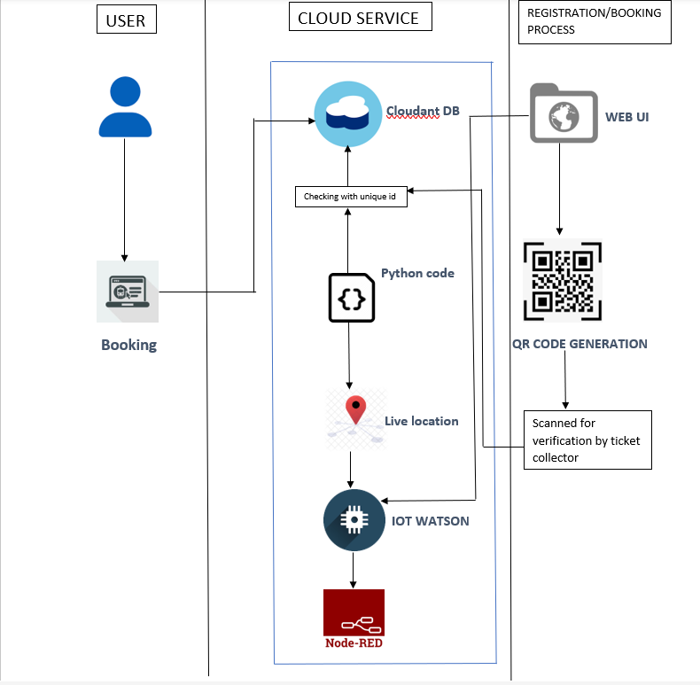

### User Stories

|  |  |  |  |  |  |  |
| --- | --- | --- | --- | --- | --- | --- |
| User type | Functional  Requirement s (Epic) | User  Story  Number | User Story / Task | Acceptance criteria | Priority | Rel eas e |
| Custo mer (Mobil  e user) | Ticket reservation using QR code | USN-1 | The user can reserve for the application by entering the user registered email id, password, and confirming password. | user can access the account / dashboard | High | Spri nt-1 |
| Custo mer (Mobil  e user) | Ticket reservation using QR code | USN-2 | The user will receive  confirmation email once the user  have registered for the application. | User can receive the confirmation email and click confirmation. | High | Spri nt-1 |
| Custo mer (Mobil  e user) | Ticket reservation using QR code | USN-3 | The user can reserved for the application through Facebook. | The user can reserve & access the dashboard with Facebook Login. | Low | Spri nt-2 |
| Custo mer (Mobil  e user) | Check  Schedule | USN-4 | The user will see the login page.user can entering email & password. | User can log in to the application by entering email & password. | High | Spri nt-1 |
| Custo mer (Mobil  e user) | Seats available | USN-5 | The user can check to get seats available. | User can access it using database. | Medium | Spri nt-3 |

# PROJECT PLANNING & SCHEDULING

## Sprint Planning & Estimation

|  |  |
| --- | --- |
| **Step-1** | **Identify the problem** |
| **Step-2** | **Prepare an abstract, problem statement** |
| **Step-3** | **List required objects needed** |
| **Step-4** | **Create a code and run it** |
| **Step-5** | **Make a prototype** |
| **Step-6** | **Test with the created code and check the designed prototype is working** |
| **Step-7** | **Solution for the problem is found** |

# JIRA REPORT

## Sprint-1

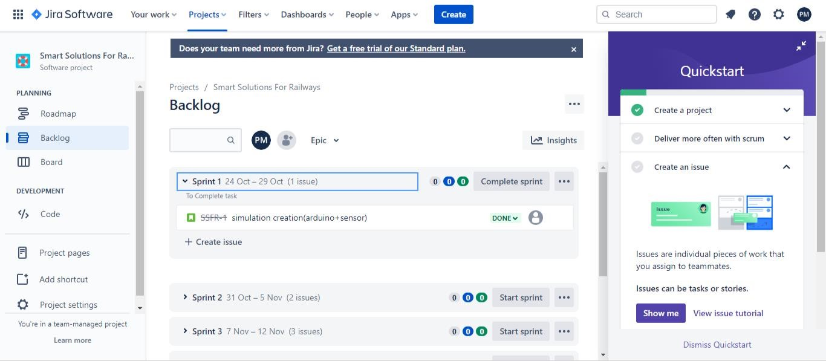

## Sprint-2

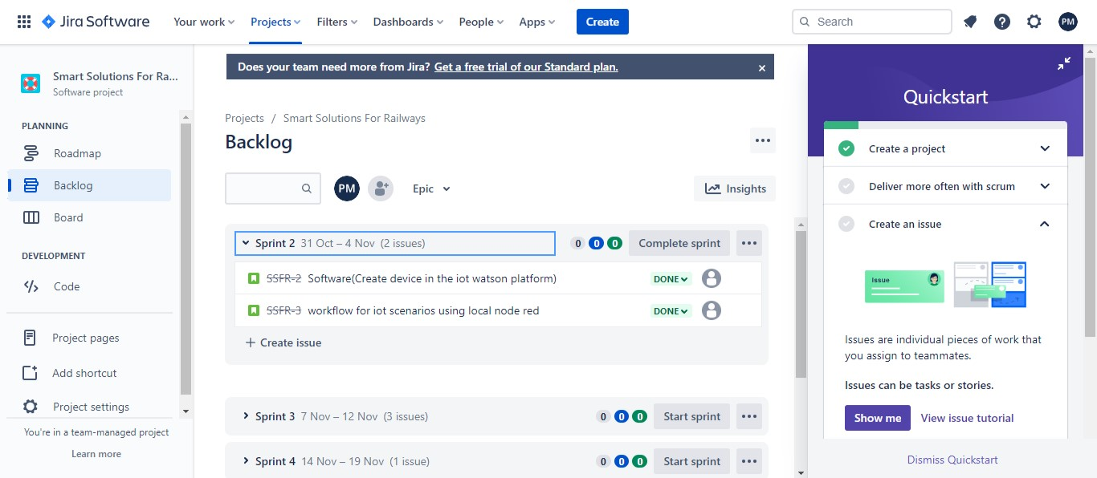

## Sprint-3

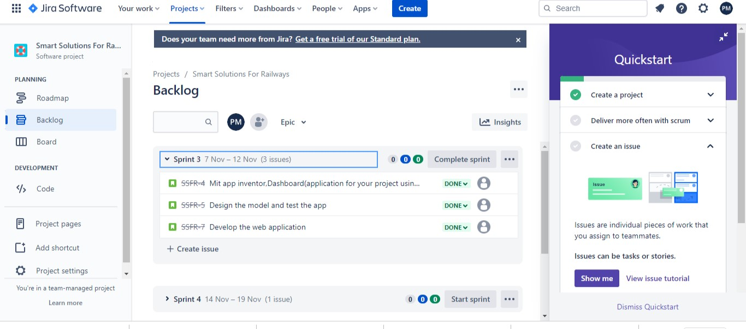

## Sprint-4

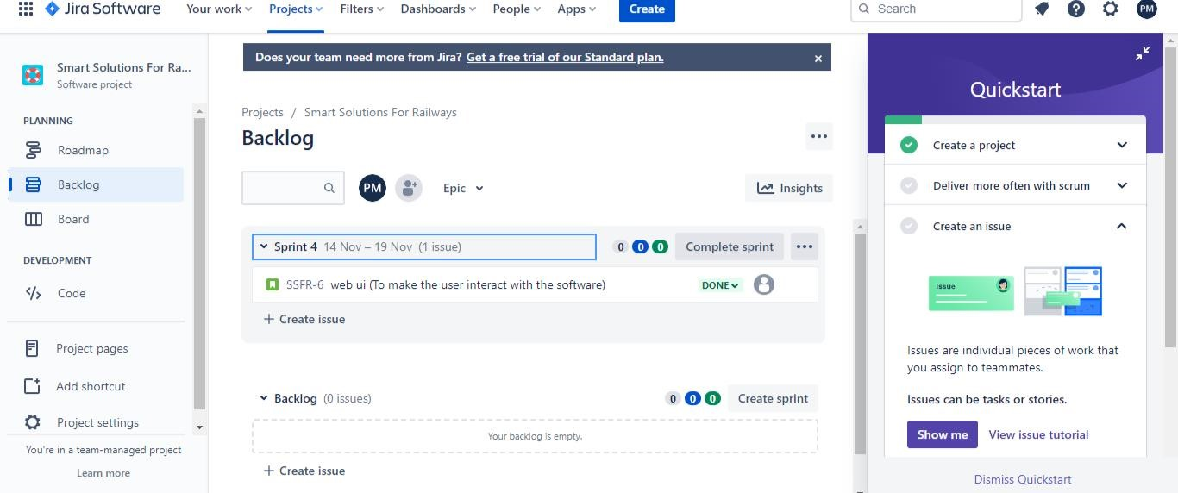

## CODING & SOLUTIONING Feature 1

* IOT Device
* IBM Watson Platform
* Node -RED
* Cloudant DB
* Web UI
* MIT App Inventor
* Python code

## Feature 2

* Login
* Verification
* Ticket Book

## TESTING

## Test Case1

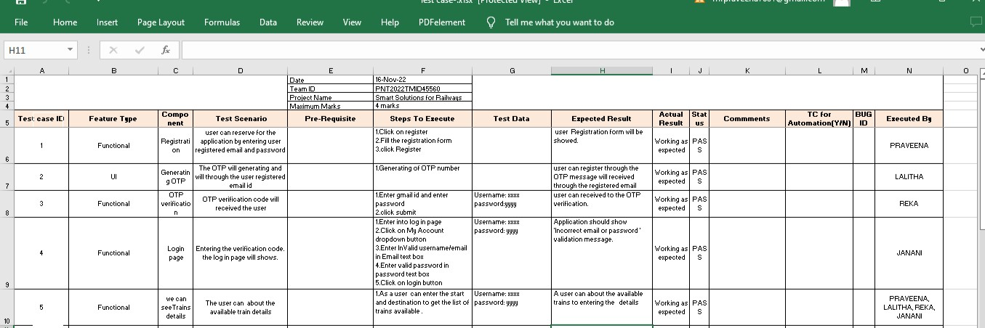

# Test case2

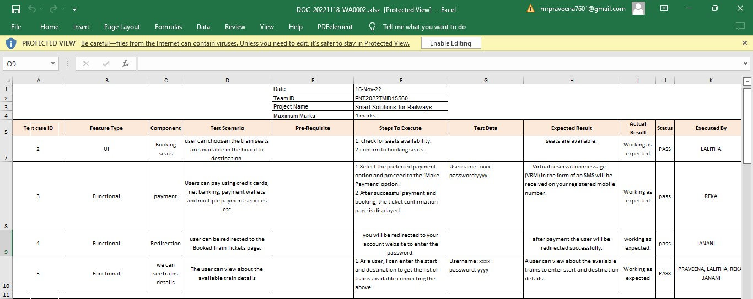

# Test case3

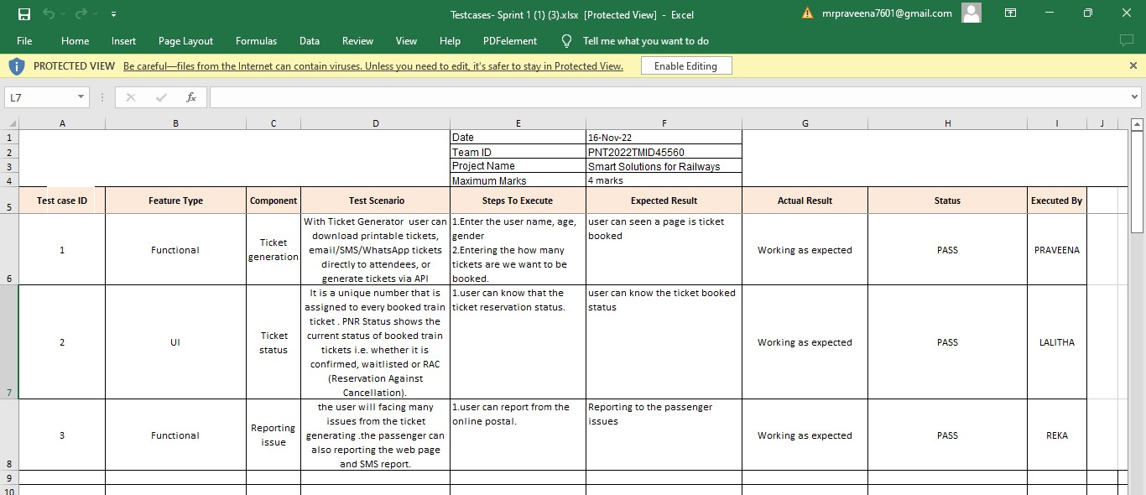

# Test case4

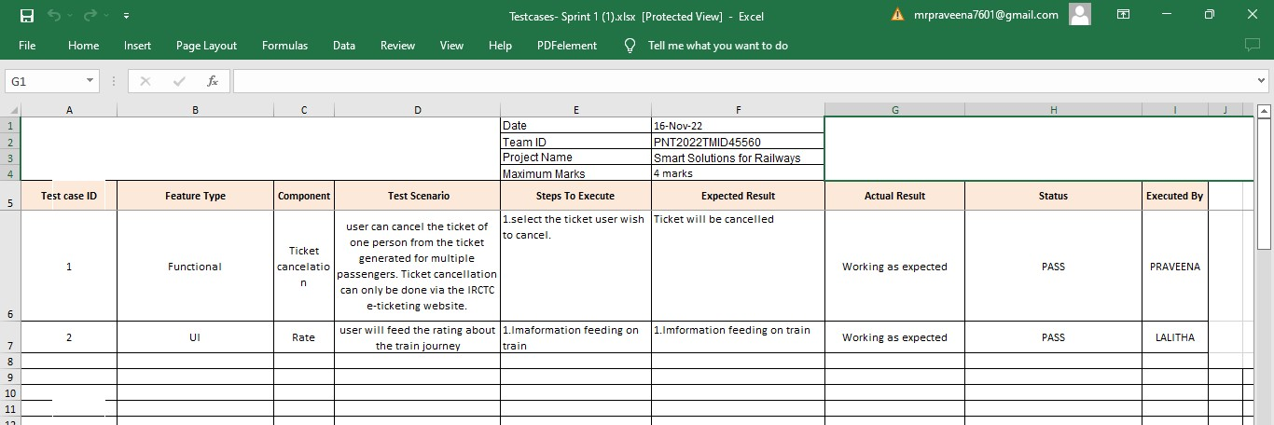

# ADVANTAGES

* The passengers can use this application, while they are travelling alone to ensure their safety.
* It is easy to use.
* Smart Solutions for railways is designed to reduced the work load of the user and also the use of paper.

**DISADVANDAGE**

* Network issues may arise.

# CONCLUSION

Almost all the countries across the globe strive to meet the demand for

safe, fast, and reliable rail services. Lack of operational efficiency and reliability, safety, and security issues, besides aging railway systems and practices are haunting various countries to bring about a change in their existing rail infrastructure. The global rail industry struggles to meet the increasing demand for freight and passenger transportation due to lack of optimized use of rail network and inefficient use of rail assets. Often, they suffer from the lack in smart technologies and latest technological updates to provide the most efficient passenger service

Most significant improvements have been evidenced by more informative and user-friendly websites, mobile applications for real-time information about vehicles in motion, and eticket purchases and timetable information implemented at stations and stops. With the rise of Industry, railway companies can now ensure that they are prepared to avoid the surprise of equipment downtime. Like above mentioned, the developed application of our project can lead the passenger who travel can travel safely without any fear

.

# FUTURE SCOPE

This application is ensured for safety for the passengers while they are travelling alone as well as they travel with their family or friends. In future, this application may also be used by passengers who travel through bus. By further enhancement of the application the passengers can explore more features regarding their safety.

# APPENDIX Source Code Ticket booking

import wiotp.sdk.device import time import random myConfig = { "identity": {

"orgId":"i63nvt",

"devicetypeId":"GPS1",

"deviceId":"i2345"

},

"auth":{

"token":"abcdefghij"

}

} def myCommandCallback(cmd):

print("Message received from IBM IOT Platform: %s" % cmd.data['command']) m=cmd.data['command']

'client = wiotp.sdk.device.DeviceClient(config=myConfig, logHandlers=None)' 'clieznt.connect()'

def pub (data):

'client.publishEvent(eventId="status", msgFormat="json",data=mydata, qos=0, onPublish=None)' print("published data successfully: %s", mydata)

while True:

mydata={'name':'Train1','lat':17.6387448,'lon': 78.4754336} pub(mydata) time.sleep(3)

#mydata={'name':'Train2','lat':17.6387448,'lon': 78.4754336}

#pub(mydata) #time.sleep(3)

mydata={'name':'Train1','lat':17.6341908,'lon': 78.4744722} pub(mydata) time.sleep(3)

mydata={'name':'Train1','lat':17.6340889,'lon': 78.4745052} pub(mydata) time.sleep(3)

mydata={'name':'Train1','lat':17.6248626,'lon': 78.4720259} pub(mydata) time.sleep(3)

mydata={'name':'Train1','lat':17.6188577,'lon': 78.4698726} pub(mydata) time.sleep(3)

mydata={'name':'Train1','lat':17.6132382,'lon': 78.4707318} pub(mydata) time.sleep(3)

client.commandCallback=mycommanCallbak client.disconnect()

# QR Code generating

import cv2 import numpy as np import time

import pyzbar.pyzbar as puzbar

from ibmcloudant.cloudant_v1 import cloudantv1 from ibmcloudant import couchDbsessionAuthenticator

from ibm_cloud_sdk_core.Authenticators import BasicAuhtenticator

authenticator=BasicAuthenticator('apikey-v2-

16u3crmdpkghhxefdikvpssoh5fwezrmuup5fv5g3ubz','b0ab119f45d3e6255eabb978

')

service =cloudantv1(authenticator=authenticator) service.set_service_url('https://apikey-v2-

16u3crmdpkghhxefdikvpssoh5fwezrmuup5fv5g3ubz:b0ab119f45d3e6255eabb978')

cap = cv2.videoCapture(0) font = cv2.FONT_HERSHEY_PLAIN

while True:

_, frame = cap.read(0) decodeObjects = pyzbar.decode(frame) for obj in decodeObjects: #print("Data",obj.data) a=obj.data.decode('UTF-8')

cv2.putText(frame,"Ticket",(50, 50),font, 2,

(255,0, 0), 3)

#print(a) try:

responce = service.get_document ( db='booking', doc_id = a

).get_result() print(response) time.sleep(5) except Exception as e: print ("Not valid Ticket") time.sleep(5)

cap.imshow("Frame", frame) if cv2.waitKey(1) & 0XFF == ord('q'):

break cap.release() cv2.destroyAllWindows() client.disconnect()

**GitHub :**

[IBM-EPBL](https://github.com/IBM-EPBL)/[IBM-Project-40093-1660623327](https://github.com/IBM-EPBL/IBM-Project-40093-1660623327)

**Demo Link :**

<https://youtu.be/NXTXBszPUEE>